The Pennsylvania Dames’ Guide for How to Propose

Terminology:
- Prospective member- a woman interested in membership who has not yet been approved for membership by the Board of Managers (aka has not yet been proposed and accepted)
- Legacy- a prospective member who has a direct lineal relative who is (or was) an NSCDA member. A legacy with ties to a non-PA Dame is for information purposes only. A legacy with ties to a PA Dame needs to only show genealogical proof of relationship to the relative who is/was a NSCDA/PA member on her application IF a copy of the relative’s verified application accompanies the legacy’s application.
- Proposer - a current Pennsylvania NSCDA member in good standing who is willing to recommend and take time to assemble and lead a proposal for a prospective member. The proposer should have a good relationship with the prospective member and know them fairly well.
- Seconder (aka endorser)- a current Pennsylvania NSCDA member in good standing who knows the prospective member well enough to write a letter of recommendation to support the proposal.
- Ancestor- the approved colonial ancestor to whom a prospective member intends to show lineal descent from. This ancestor MUST be on the ROA (Register of Ancestors) prior to a candidate submitting their application.
- Candidate- a woman who has been proposed for membership and approved by the Board of Managers. A candidate may be a candidate for membership for a period of 2 years.

In The Beginning:

Prospective members come from a variety of places. Some may be local friends or acquaintances from other societies, and some are unknown to us, but seek us out. It is through our process of proposal that we seek to learn about a prospective member and invite them to learn about us in order to make sure we, as an organization, are a good fit for each prospective member.

The Process:
- Membership Chair and/or committee members talk with prospective members about NSCDA and our purpose and objectives while getting to know the prospective member on a personal level. Do the prospective member’s interests and talents align with NSCDA? After learning about NSCDA does the prospective member see herself as an active member? It is also the task of the Membership Chair and membership committee to help the prospective member find a proposer if she doesn’t have one. It is also through this relationship building that the sensitive subject of fees and expenses may be communicated. (see attached)
- Membership Chair, membership committee members and proposer seek to find out if the prospective member has an approved ancestor listed on the ROA. We like to find this out as early as possible to prevent the possible undesired situation of a prospective member with no possible ancestor and therefore no road to membership.

To determine if a prospective member has a probable or possible ancestor communicate the general ancestor eligibility requirements with them: significant service prior to July 5, 1776 (but including the signers of the Declaration of Independence). Specific state society ancestor eligibility requirements can be found on the national website when signed in as a member.

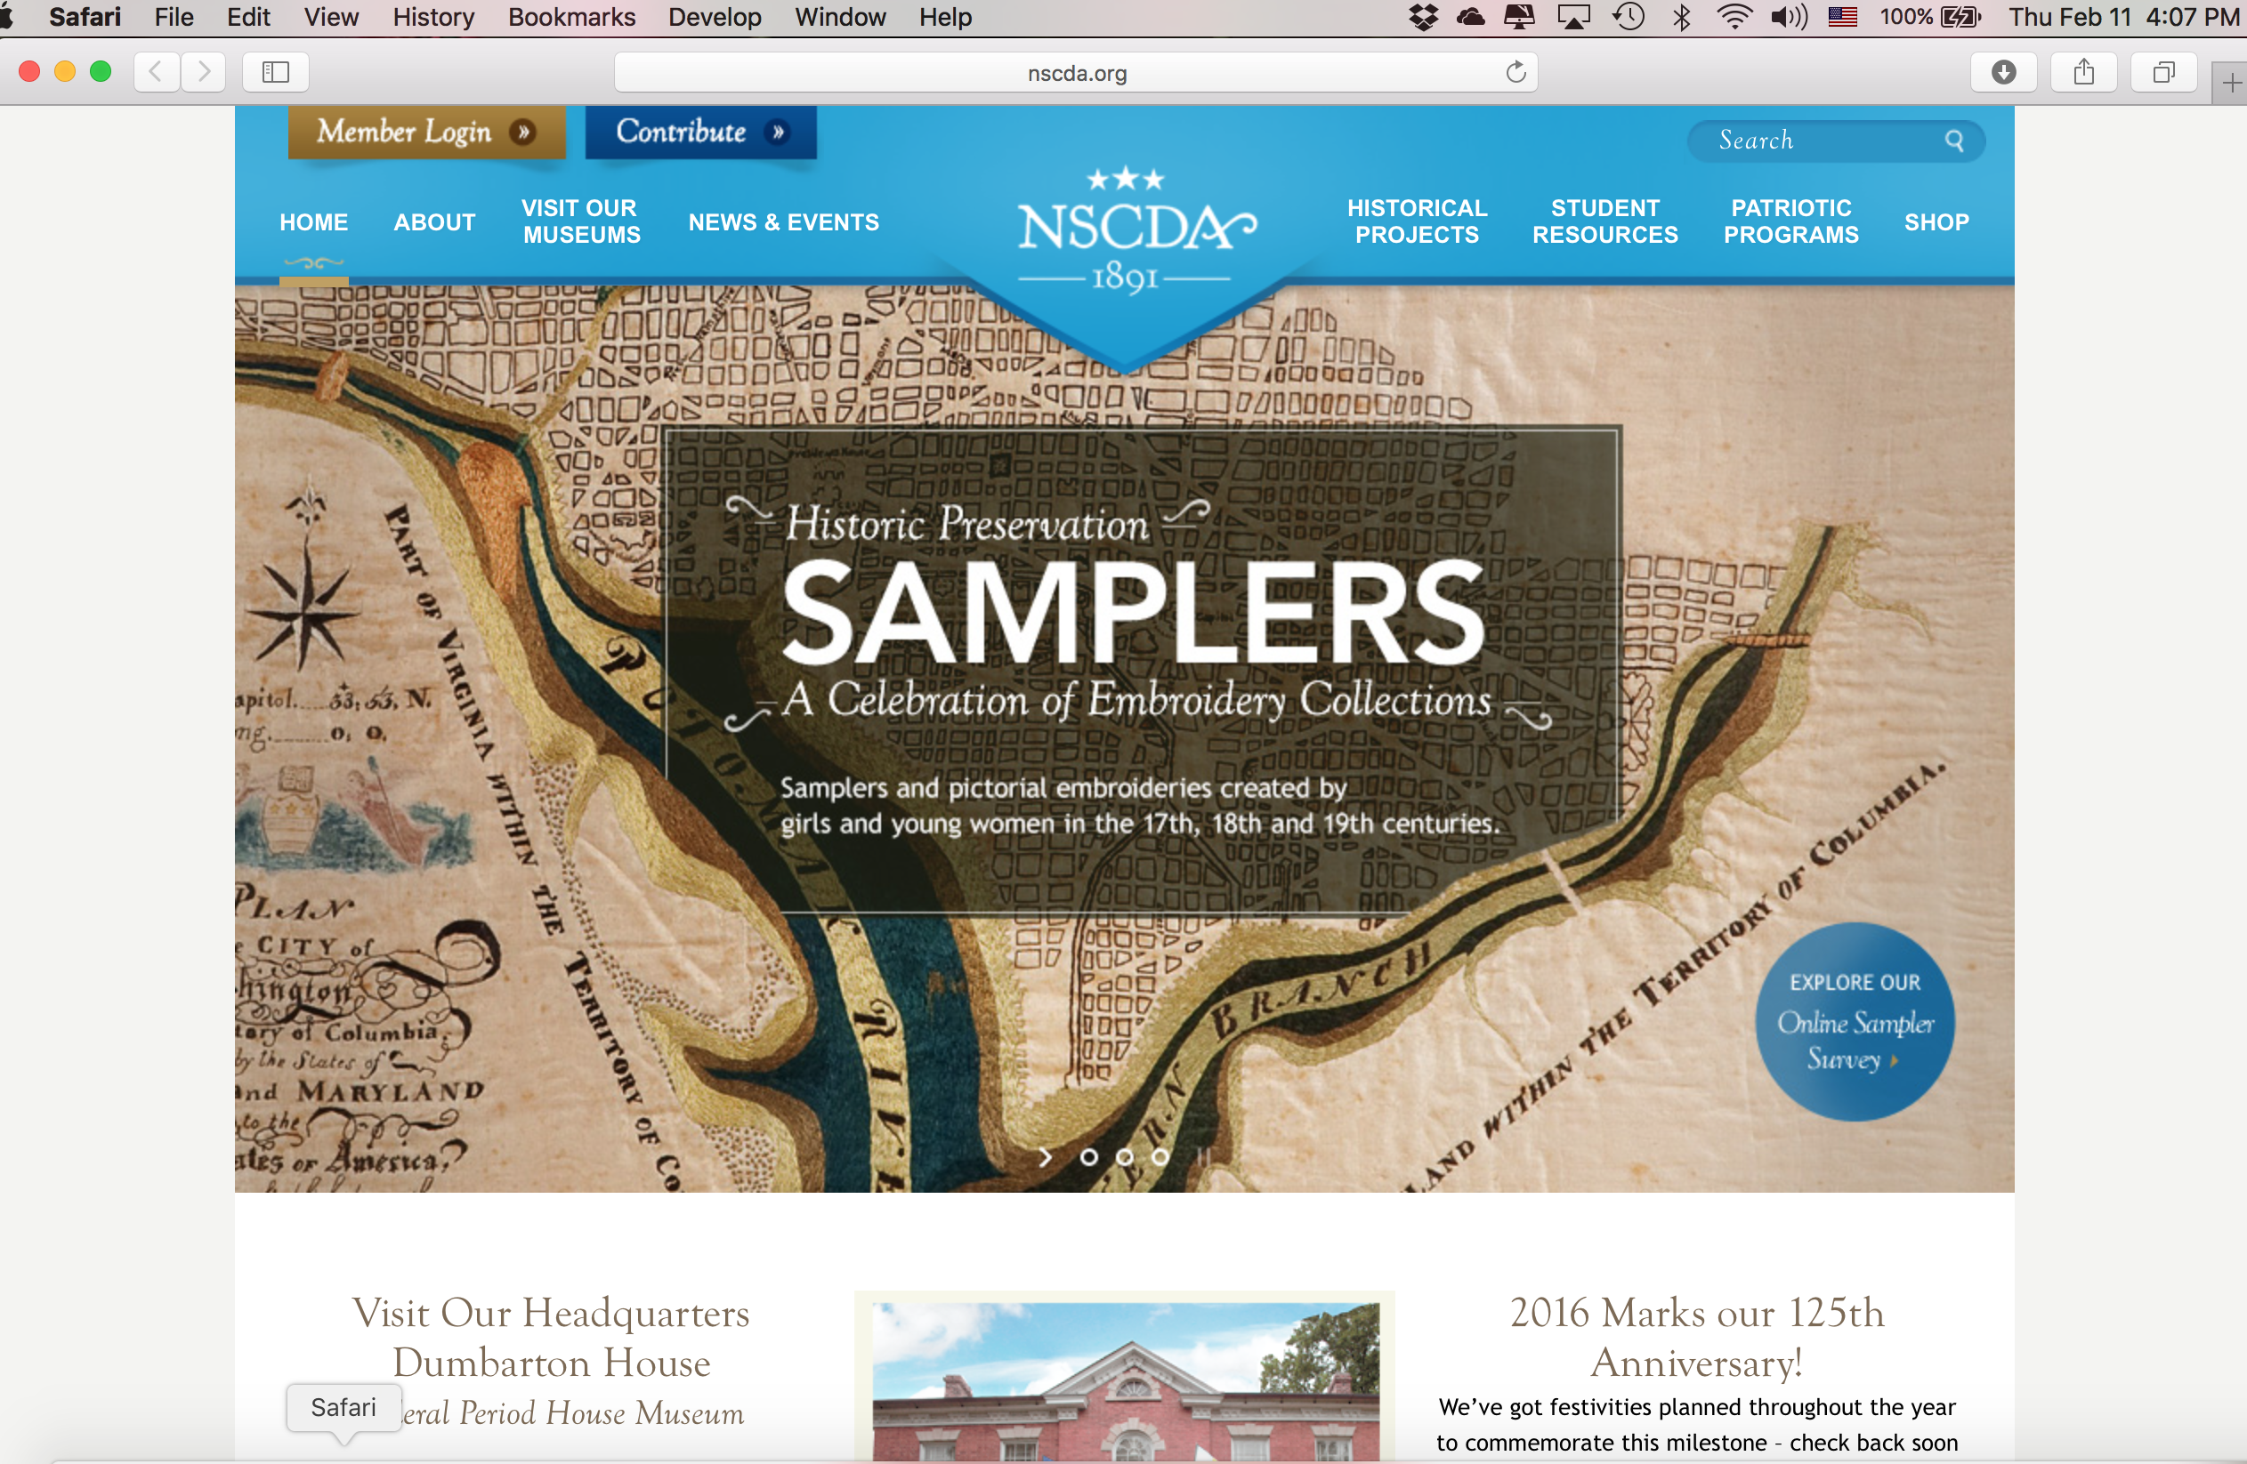
www.nscda.org
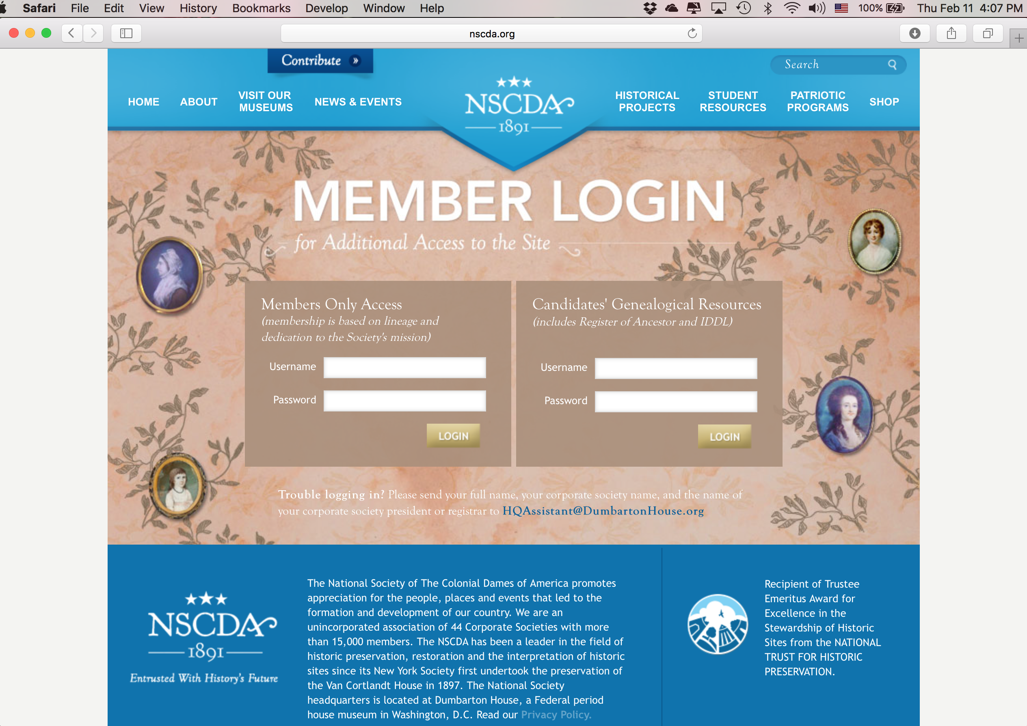
Login as a member:

history

future

Members’ Area:
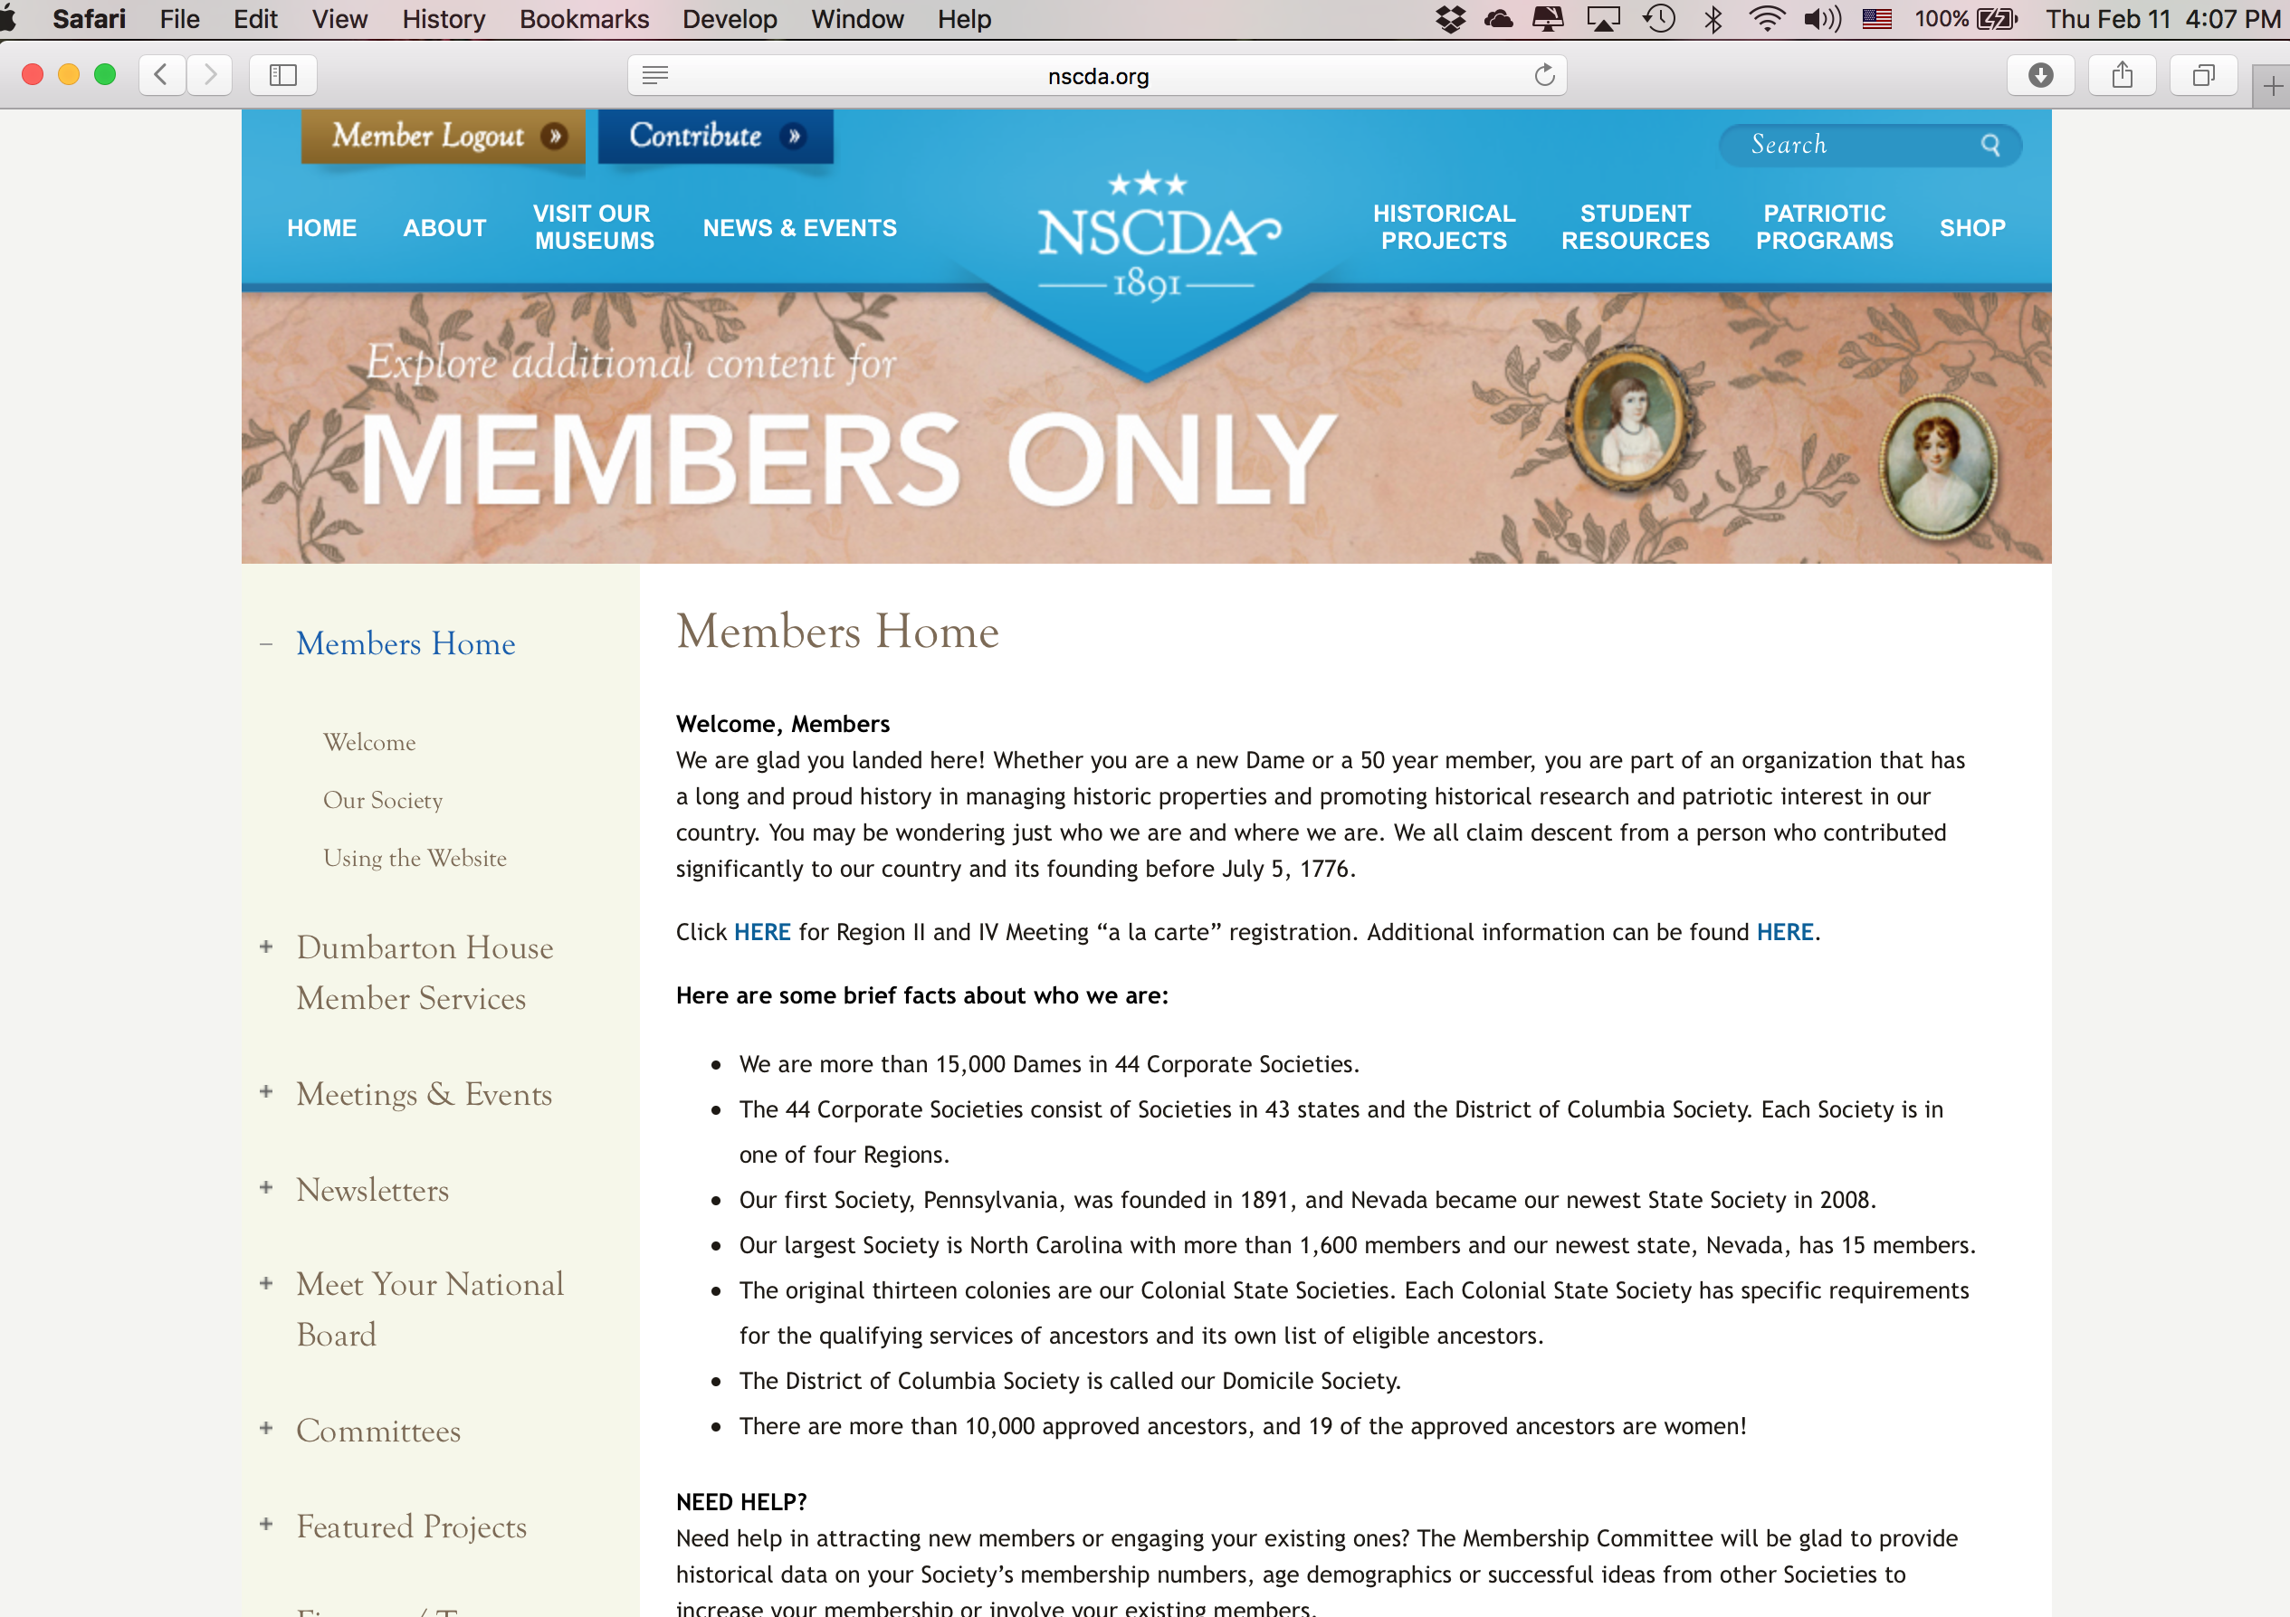

Scroll down on the page. Look for the “Genealogy Resources” on the menu on the left side of the page and click on it to expand options
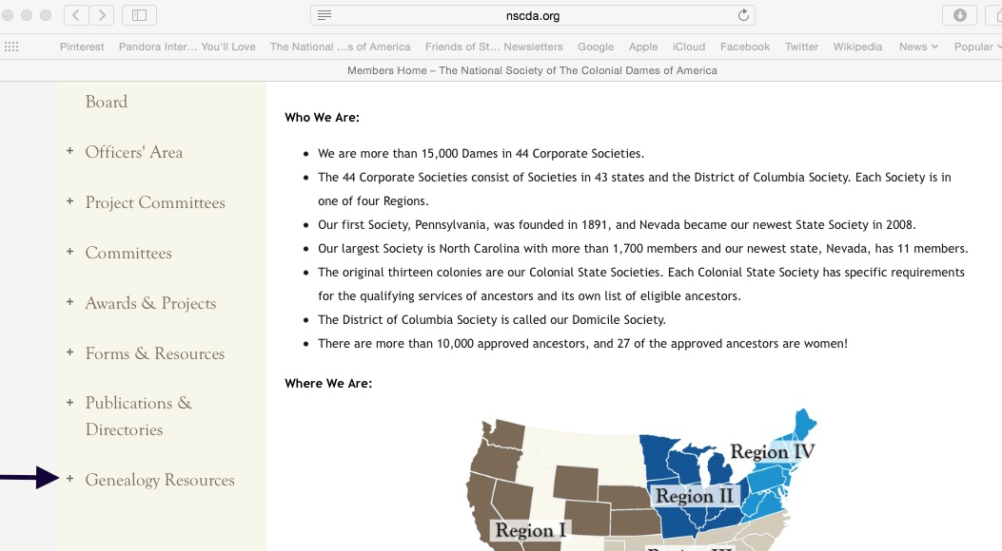

The expanded view will show you the two options you may need to use:
- ROA (Register of Ancestors) and 2. Research Lists and Forms
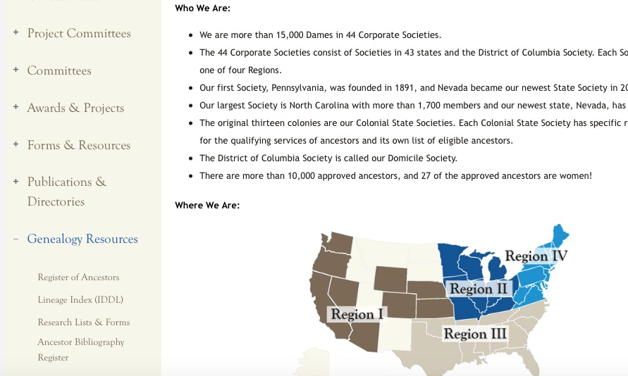
If you click on the Lists and Forms, you’ll find Eligibility Lists. Clicking on that will open a pdf document on your computer. It will have the list from each colonial society specifying what is considered service for an ancestor from that state. This is helpful when working with a prospective member whose ancestors are from outside of Pennsylvania.

If you click on Register of Ancestors, a search engine will appear:
Enter either a last name OR search through all ancestors for a Colonial State. Keep in mind spelling counts so try alternate spellings. Also, make sure if you are looking for a particular ancestor that you find the one from the correct Colonial State (there is probably more than 1 John Smith).

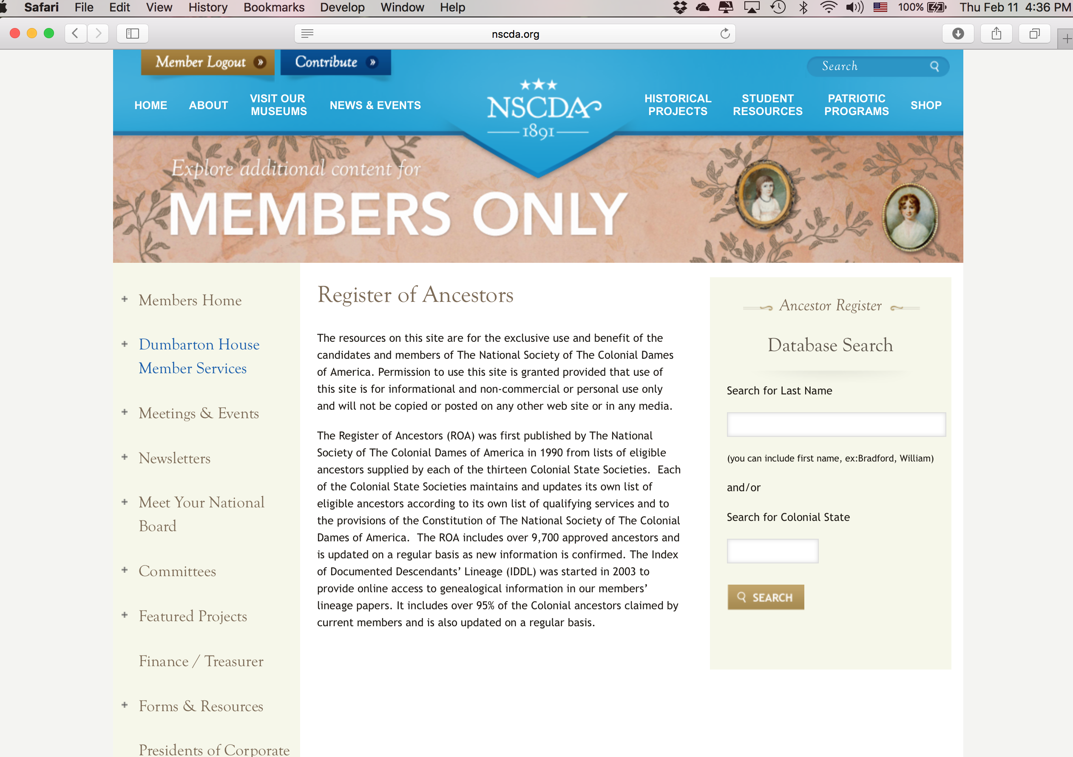

OR

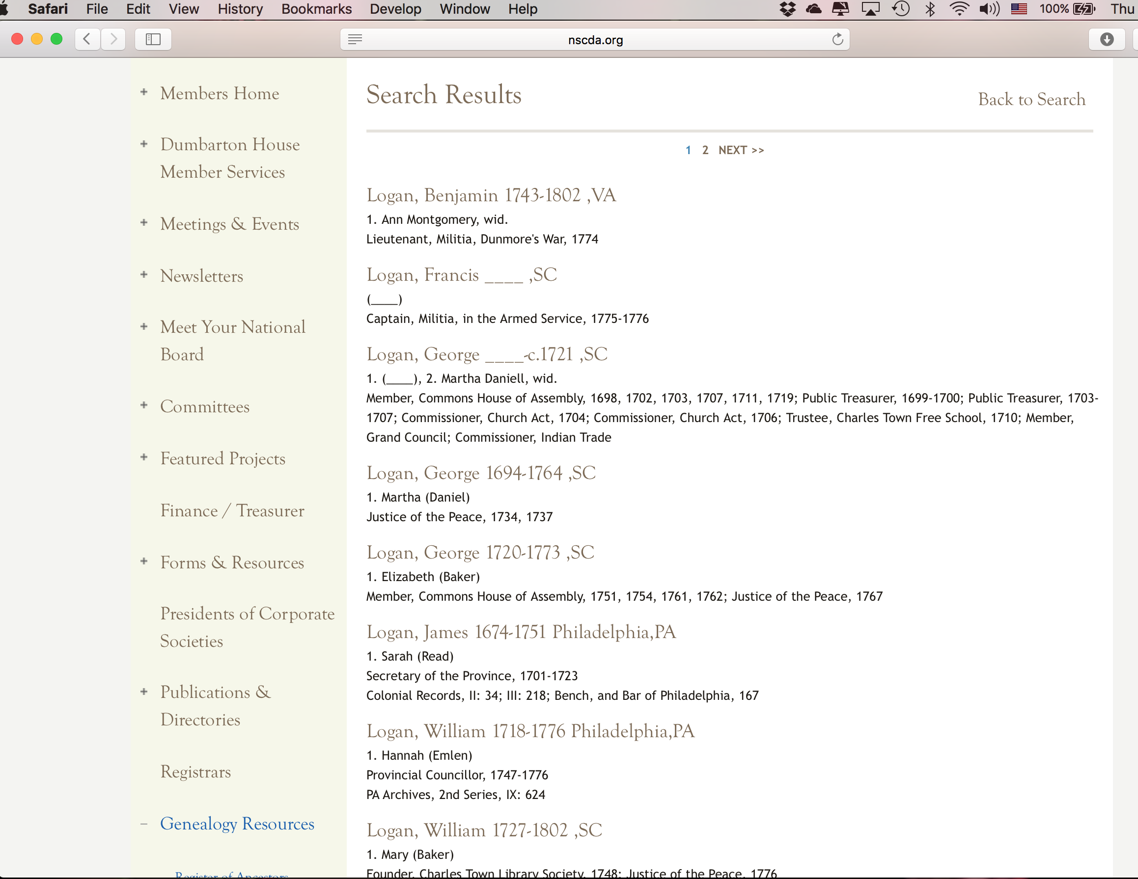
Example of search results for “Logan”

When ready to propose a prospective member, copy the name, dates, place and service exactly onto the proposal form (see attached).

The Process continued…

- After the Membership Chair and membership committee feel a prospective member is ready to move forward in the process, they ensure there are current NSCDA/PA members who will act as a proposer and seconder.
- IF the prospective member DOES NOT have an ancestor on the ROA, but feels she has one that meets eligibility requirements, she works with the Registrar to get the ancestor added. This should be done as soon as possible and may be done prior to the actual proposal.

NOTE: If there is no approved ancestor and the prospective member does not feel she has one that meets the eligibility requirements, then the entire process ends. The key element here is that if there is no ancestor on the ROA, the rest of the process is moot. There will be no forward movement without an approved ancestor.

- Once an eligible ancestor is identified, the proposer takes over and completes the proposal form. The proposal form is a fillable pdf so it can (and should) be typed on a computer. Alternately it may be printed and typed on a typewriter, but it must be typed (per our bylaws). The form is for use by our members and should not be given to the prospective member. The proposer is to list the information for the prospective member, including ancestor, and sign the form as well as secure the signature of the seconder. Additionally, the proposer is to write a letter of recommendation and obtain a second letter of recommendation from the seconder. When all of these details have been addressed, the proposal package is then given to the Membership Chair.

- The Membership Chair will bring the proposal to the Board of Managers (at the next convenient Board meeting) and read the letters of recommendation. The Board will then vote on whether or not to accept the prospective member as a candidate for membership, OR may table the motion to provide the Board additional time for consideration, and/or any needed clarification of proposal information, before a vote.

What happens next?

After the Board vote, the Membership Chair will inform the candidate if she has become a candidate or not. If she has, the Registrar sends a “Welcome Candidate” packet to the new candidate explaining the rest of the membership process. The candidate then has 2 years to complete the application and submit it to the Registrar who forwards it to the verifying genealogist. As soon as the verifying genealogist approves the application, the candidate is given a number and becomes a member.

